Covid-19 Vaccines – How do they work?

Covid-19 is named after the coronavirus that causes this disease, which was discovered in 2019. A person who has been infected with the coronavirus may have no symptoms, mild or moderate illness, or severe Covid-19 that results in hospitalization and/or death. The risk of developing severe Covid-19 is much lower for:
- people who have been vaccinated against Covid-19
- people who have already had Covid-19 in the past.
To understand the reasons for this reduced risk of severe Covid-19, you first need to learn about the immune response that fights a coronavirus infection.

Immune Defenses against Coronavirus Infection
When a person is infected with the coronavirus, his or her immune cells produce proteins called antibodies. Some of these antibodies can bind to the spike protein on the surface of coronaviruses.  1a. Circle a spike protein on the coronavirus in this figure.  1b. What is the function of the spike protein? | 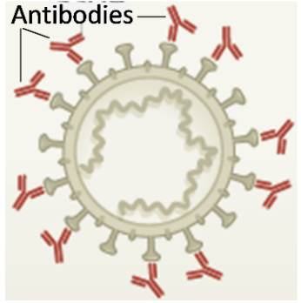

1c. How can antibodies that bind to the spike protein help to fight a coronavirus infection?

An antigen is a specific molecule in a specific virus that stimulates the immune system to respond. In the above example, the antigen was the spike protein of the coronavirus.

A cell that has been infected with the coronavirus has viral antigens on the cell surface. A cytotoxic T cell can bind to these viral antigens and kill the infected cell. Phagocytic cells help to dispose of coronaviruses and dead infected cells.  2. Why is it helpful for cytotoxic | 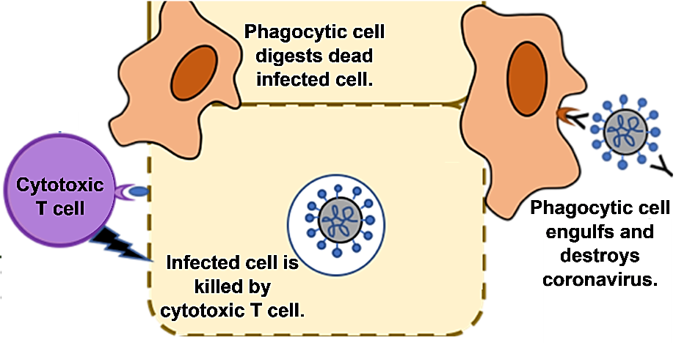
T cells to kill cells infected with the coronavirus?

3. Based on this information, suggest a hypothesis to explain how vaccination and previous infection reduce the risk of severe Covid-19 in the future.

These graphs show the change in the concentration of antibodies in the blood after a person has been exposed to the coronavirus the first time (A) and then later a second time (B).

4. Describe the differences between the antibody response after the first vs. second exposure to coronavirus.

This cartoon figure shows what happens when a person is exposed to the coronavirus for the first time. Notice the multiple steps that are needed before the immune system can produce antibodies.

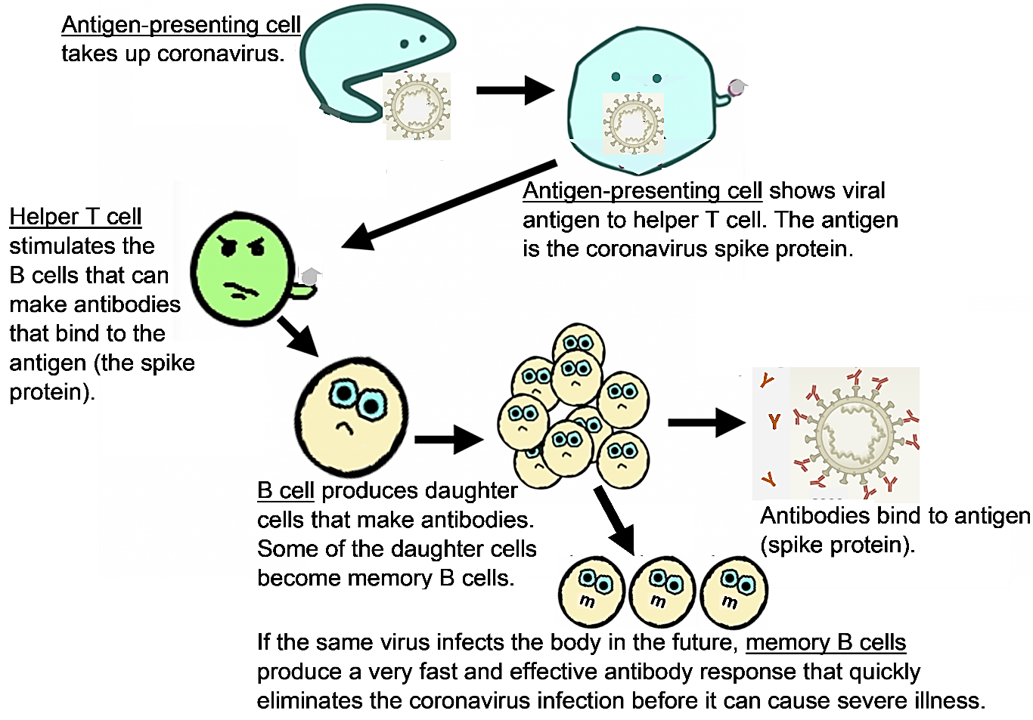

5. Which type of cell divides to produce daughter cells that make antibodies that can bind to coronavirus antigens? antigen-presenting cell ___ helper T cell ___ B cell ___

6a. Why does it take 2-3 weeks to reach peak antibody production after the first exposure to the coronavirus? What needs to happen before the immune system can produce lots of antibodies?

6b. How is the body able to produce a faster, stronger antibody response to a second infection?

When a person has a coronavirus infection, helper T cells also stimulate the cytotoxic T cells that can kill cells infected with the coronavirus. These cytotoxic T cells and the helper T cells make memory cells, which contribute to a faster, stronger immune response if the person is exposed to the coronavirus again in the future.

How Covid-19 Vaccines Work

The first two Covid-19 vaccines approved for use in the US were both mRNA vaccines. This figure shows that an mRNA vaccine uses your body’s cells to make spike proteins. These spike proteins are the antigens that stimulate an immune response.  7a. In the figure, circle the antigen that stimulates the immune response.  7b. How is the antigen produced after an mRNA vaccine has been injected?  The bottom half of this figure shows the immune response to vaccination. Notice that this response is very similar to the immune response to a coronavirus infection.  8a. Underline the names of the three types of cells that will result in a faster, stronger immune response to any future coronavirus infection.  8b. A second vaccine injection results in even stronger protection against Covid-19. What changes in the immune system could result in this stronger protection?  8c. Suggest reasons why a vaccinated person could benefit from a third vaccine injection (a booster shot).  9. Explain why a person cannot get Covid-19 from the mRNA vaccines. | 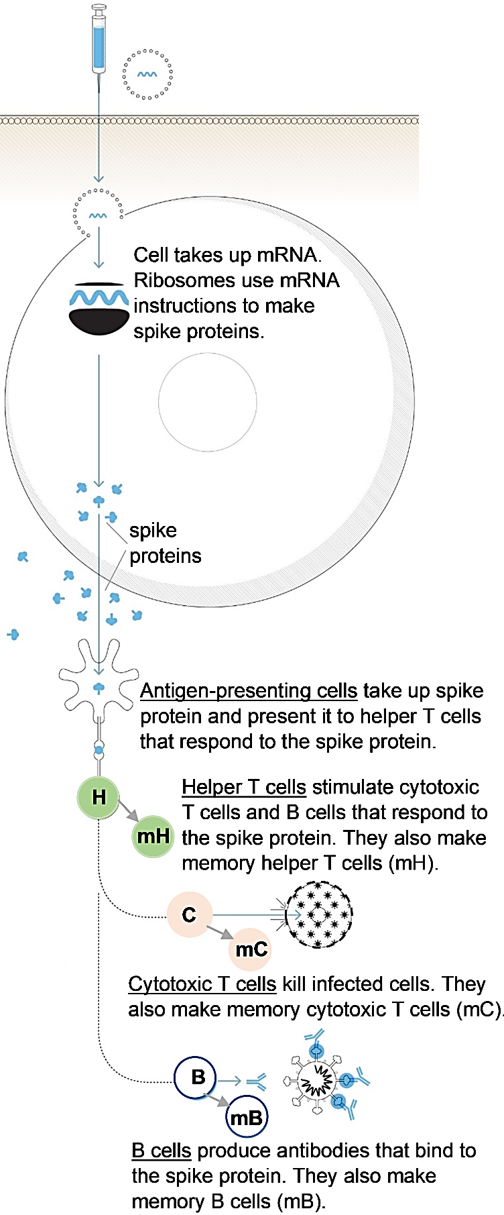

In an infected person, the number of coronaviruses increases each day until the person’s immune response is strong enough to stop the infection.  In a person who has not been vaccinated or had Covid-19, the immune response to a coronavirus infection is slow. This allows more time for the coronavirus population to grow larger, so a bigger immune response is needed to control the coronavirus infection. The large coronavirus population and big immune response can result in severe Covid-19.  10. How does a vaccinated person’s immune system | 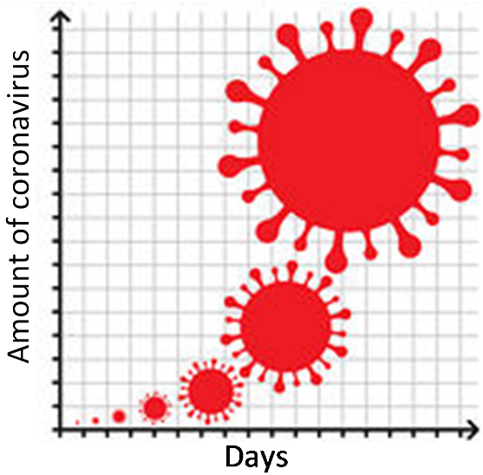
stop the growth of a coronavirus population while it is still very small?

The immunity that results from vaccination often stops the growth of a coronavirus population while it is so small that the person never feels sick. However, vaccination is not a 100% guarantee that a person will not get sick. For example, the following results were observed in a clinical trial that compared approximately 13,000 people who received an mRNA vaccine with approximately the same number of people who received a placebo injection.

 | Vaccinated | Placebo
Number of cases of mild or moderate Covid-19 | 11 | 155
Number of cases of severe Covid-19 | 0 | 30

11. Propose a hypothesis to explain why none of the people who had been vaccinated developed severe Covid-19, but a few of the vaccinated people developed mild or moderate Covid-19.

Although vaccines can help to end the pandemic, we need to recognize some major limitations.
- The coronavirus keeps mutating and evolving. Current immune defenses are less effective against the new variants of the coronavirus. Fortunately, most vaccinated people continue to be protected against severe Covid-19.
- Weak immune systems are common among elderly people and patients who are receiving certain medical treatments, so these people are more likely to get severe Covid-19, even if they are vaccinated.

12. How can you help to protect people you interact with who may have weak immune systems and therefore may be vulnerable to severe Covid-19?

By Dr. Ingrid Waldron, Dept Biology, Univ Pennsylvania, © 2022; this Student Handout and Teacher Notes (with instructional suggestions and background biology) are available at https://serendipstudio.org/exchange/bioactivities/coronavirusvaccine.

